[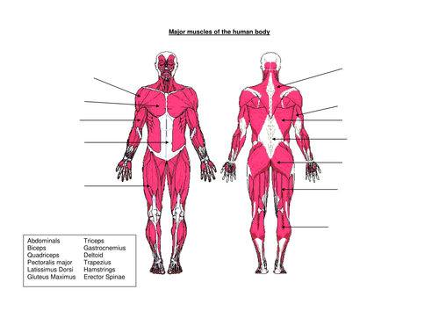](https://www.google.com/url?sa=i&rct=j&q=&esrc=s&source=imgres&cd=&cad=rja&uact=8&ved=2ahUKEwiexI-GyaTnAhUUFTQIHWMbCnUQjRx6BAgBEAQ&url=https%3A%2F%2Fwww.tes.com%2Fteaching-resource%2Fmuscles-of-the-human-body-6077821&psig=AOvVaw1GYP6-VgSgTZDDRwsbwKJL&ust=1580241655829609)

Name: ___________________________________ **Physical & Health Education with Ms. Newell**

Grade: ______

MAJOR MUSCLES OF THE HUMAN BODY

1. Deltoids
2. Biceps
3. Abdominals (Abs)
4. Quadriceps (Quads)
5. Triceps
6. Gluteus Maximus (Glutes)
7. Hamstrings
8. Gastrocnemius (Calf)